DECLARE

v_Salary employees2.salary%TYPE;

BEGIN

SELECT salary INTO v_Salary

FROM EMPLOYEES2;

DBMS_OUTPUT.PUT_LINE(' Salary is : '||v_Salary);

END; 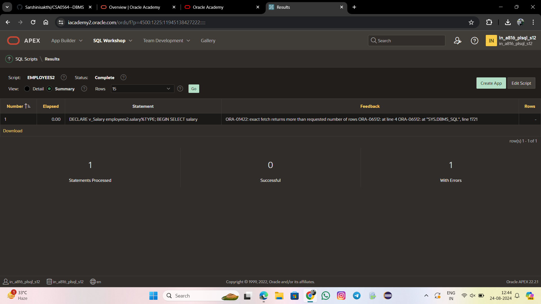

DECLARE

CURSOR cur_emps IS

SELECT NAMES, SALARY FROM EMPLOYEES2 ;

v_NAMES EMPLOYEES2.NAMES%TYPE;

v_SALARY EMPLOYEES2.SALARY%TYPE;

BEGIN

OPEN cur_emps;

LOOP

FETCH cur_emps INTO v_NAMES, v_SALARY;

EXIT WHEN cur_emps%NOTFOUND;

DBMS_OUTPUT.PUT_LINE(v_NAMES||' '||v_SALARY);

END LOOP;

CLOSE cur_emps;

END;

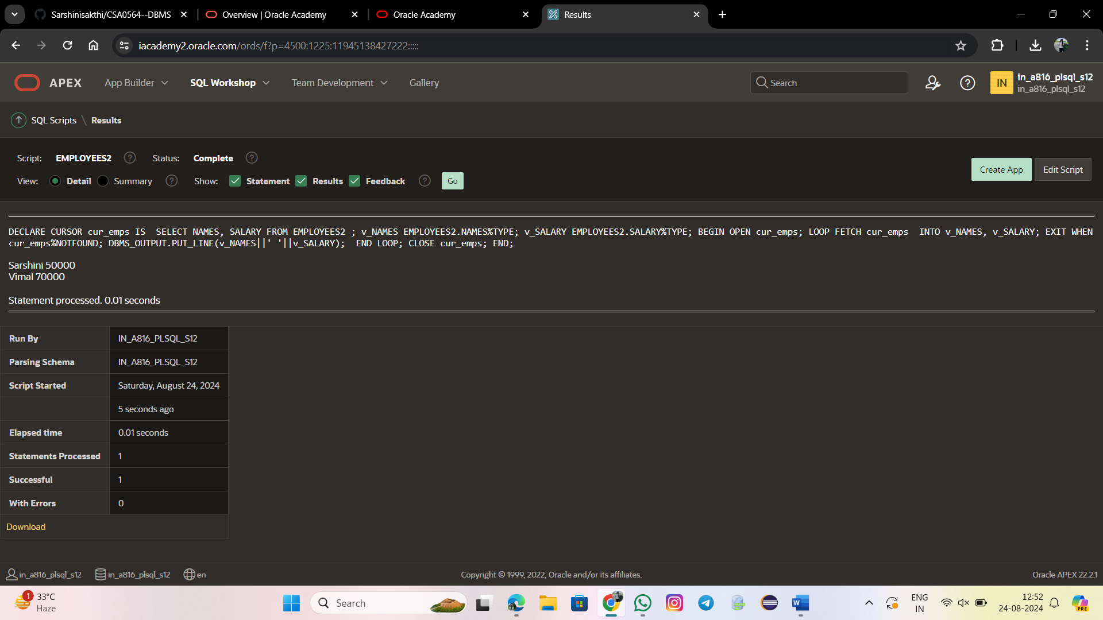

DECLARE

CURSOR emp_cursor IS

SELECT employee_id, NAMES FROM employees2

WHERE EMPLOYEE_id =30;

v_empno employees2.employee_id%TYPE;

v_name employees2.NAMES%TYPE;

BEGIN

OPEN emp_cursor;

FETCH emp_cursor INTO v_empno, v_name;

DBMS_OUTPUT.PUT_LINE( v_empno ||' '||v_name);

END;

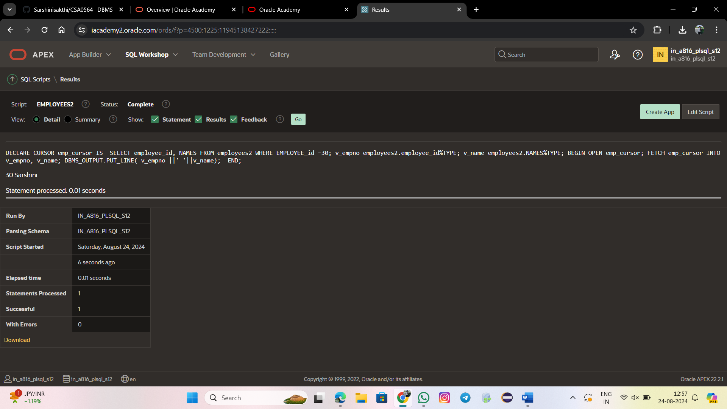

DECLARE

CURSOR cur_emps IS

SELECT EMPLOYEE_ID, SALARY FROM EMPLOYEES2;

v_empid EMPLOYEES2.EMPLOYEE_ID%TYPE;

v_sal EMPLOYEES2.SALARY%TYPE;

BEGIN

OPEN cur_emps;

LOOP

FETCH cur_emps INTO v_empid, v_sal;

EXIT WHEN cur_emps%NOTFOUND;

DBMS_OUTPUT.PUT_LINE(v_empid || ' ' || v_sal);

END LOOP;

CLOSE cur_emps;

END;

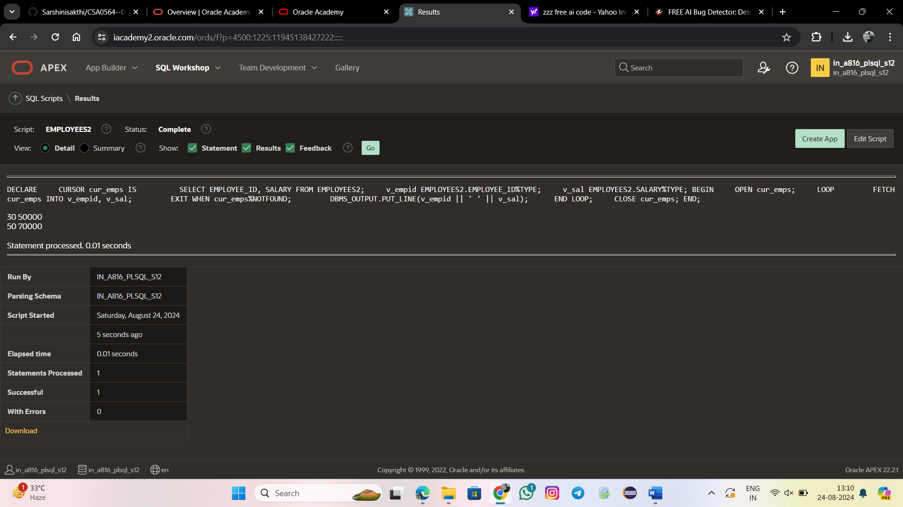

**MODULE 5.2**

DECLARE

CURSOR cur_emps IS

SELECT * FROM employees2

WHERE EMPLOYEE_id = 30;

v_emp_record cur_emps%ROWTYPE;

BEGIN

OPEN cur_emps;

LOOP

FETCH cur_emps INTO v_emp_record;

EXIT WHEN cur_emps%NOTFOUND;

DBMS_OUTPUT.PUT_LINE(v_emp_record.employee_id || ' - '

|| v_emp_record.nameS);

END LOOP;

CLOSE cur_emps;

END;

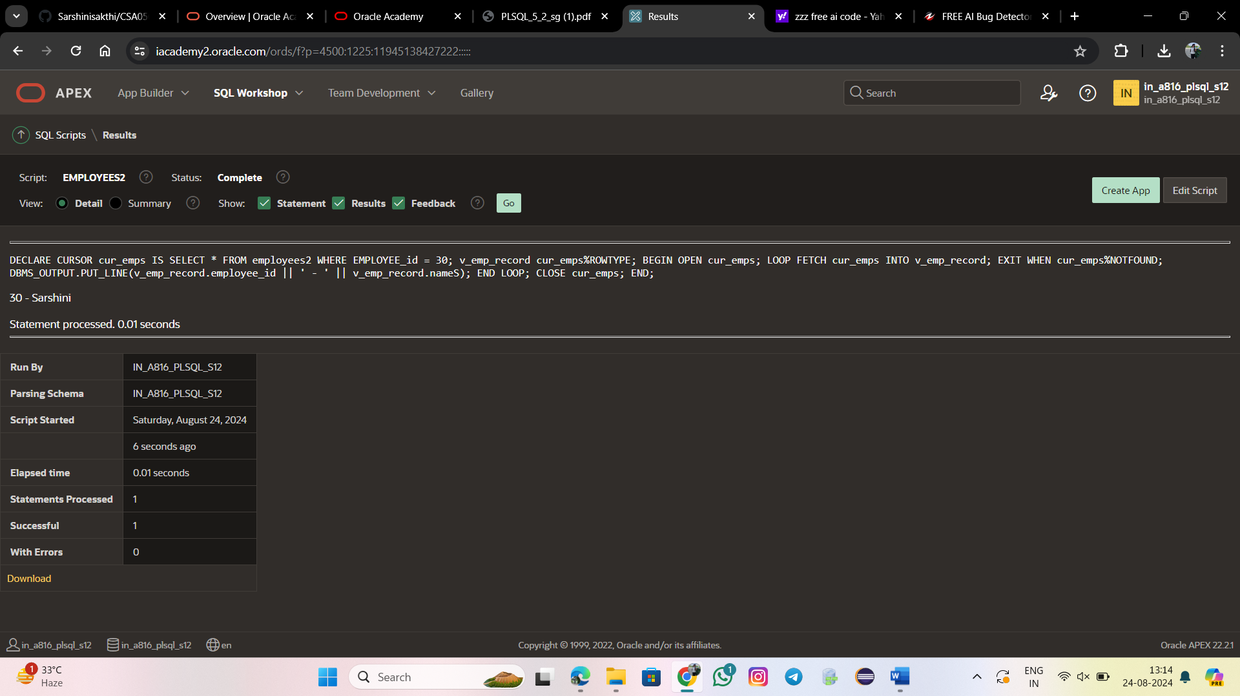

DECLARE

CURSOR cur_emps_dept IS

SELECT names, salary, employee_id

FROM employees e, employees2 d

WHERE e.employees_id = d.employee_id;

v_emp_dept_record cur_emps_dept%ROWTYPE;

BEGIN

OPEN cur_emps_dept;

LOOP

FETCH cur_emps_dept INTO v_emp_dept_record;

EXIT WHEN cur_emps_dept%NOTFOUND;

DBMS_OUTPUT.PUT_LINE(v_emp_dept_record.names || ' – '

|| v_emp_dept_record.salary|| ' – '

|| v_emp_dept_record.employee_id);

END LOOP;

CLOSE cur_emps_dept;

END;

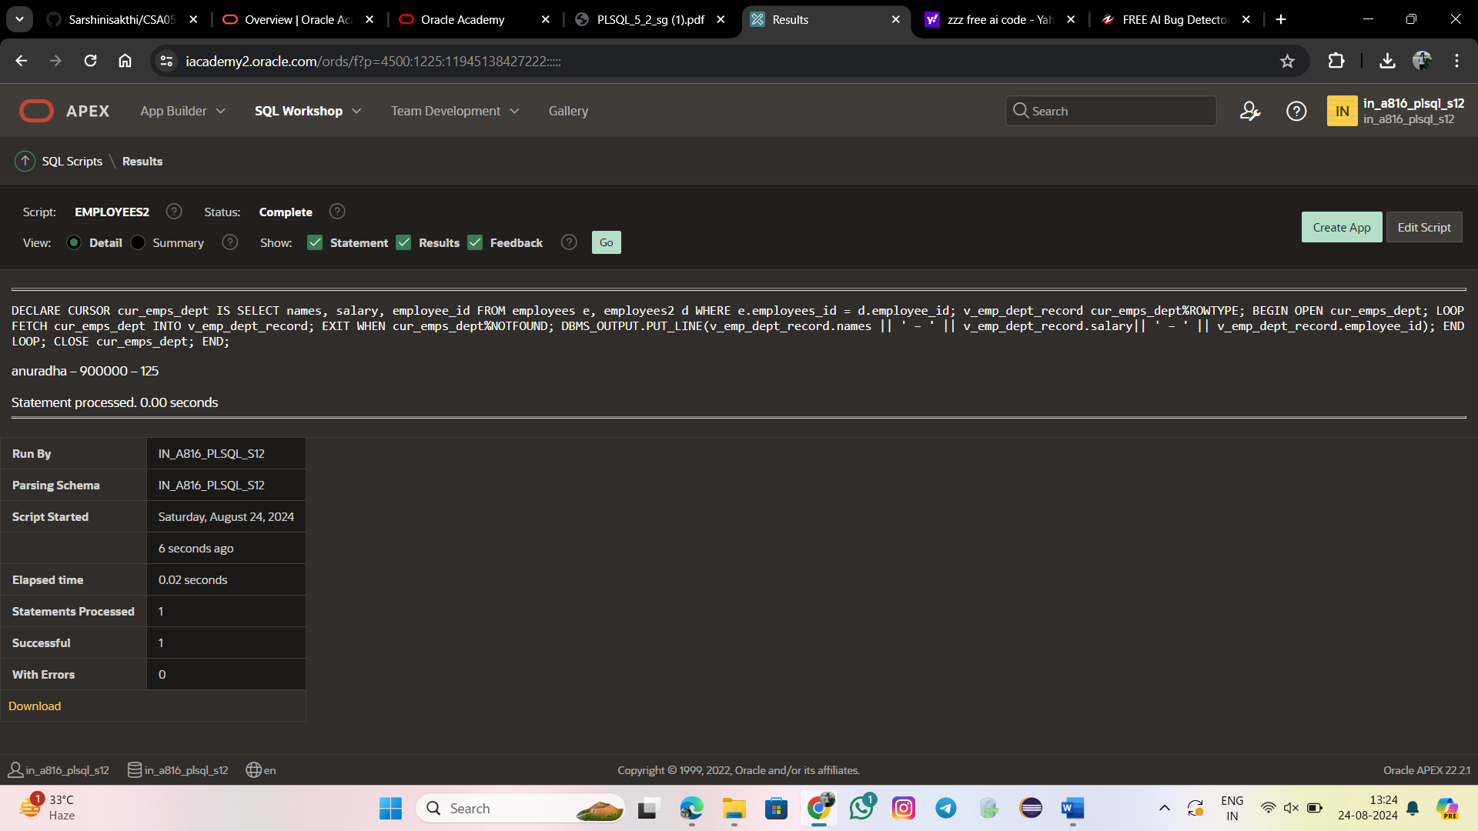

DECLARE

CURSOR cur_emps IS

SELECT employee_id, names FROM employees2;

v_emp_record cur_emps%ROWTYPE;

BEGIN

OPEN cur_emps;

LOOP

FETCH cur_emps INTO v_emp_record;

EXIT WHEN cur_emps%ROWCOUNT > 3 OR cur_emps%NOTFOUND;

DBMS_OUTPUT.PUT_LINE(v_emp_record.employee_id || ' ' || v_emp_record.names);

END LOOP;

CLOSE cur_emps;

END;

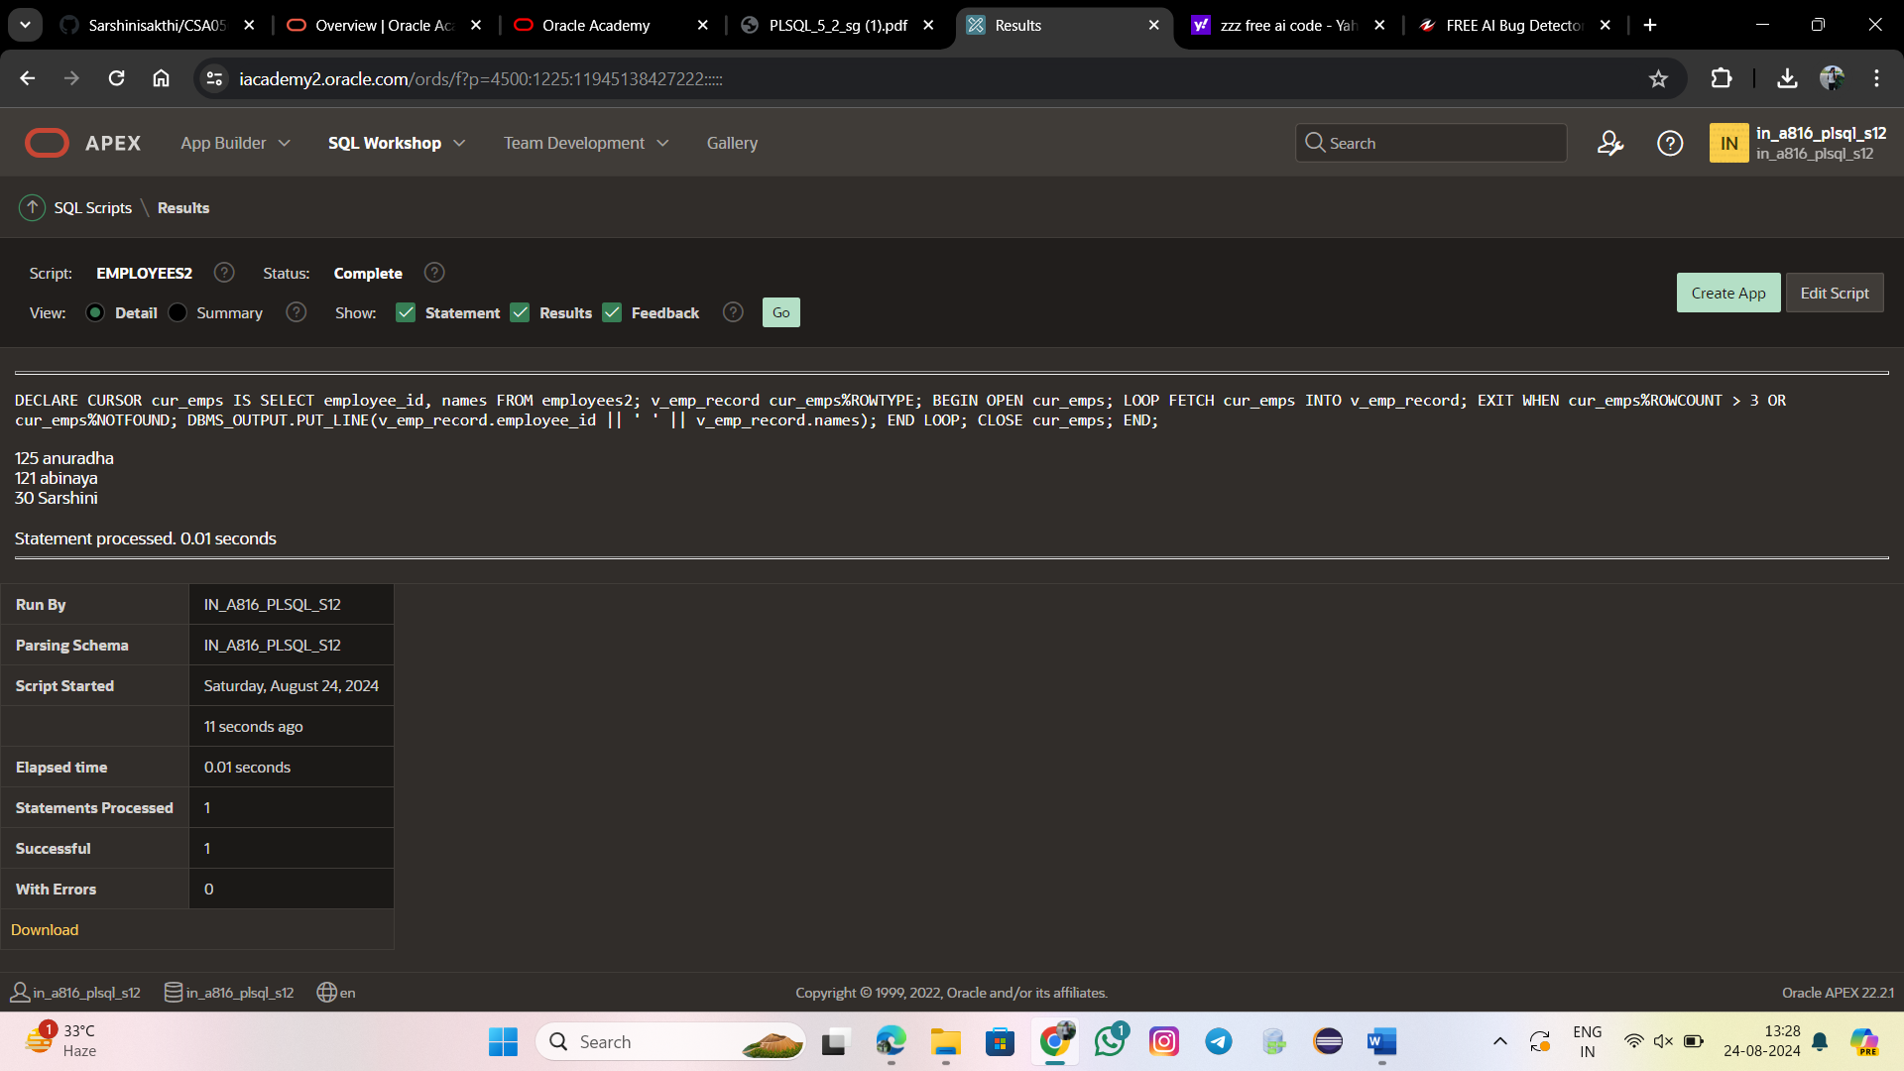

DECLARE

CURSOR cur_emps IS

SELECT employee_id, salary

FROM EMPLOYEES2

ORDER BY salary DESC;

v_emp_record cur_emps%ROWTYPE;

v_rowcount NUMBER; -- variable to store the cursor row count

BEGIN

OPEN cur_emps;

LOOP

FETCH cur_emps INTO v_emp_record;

EXIT WHEN cur_emps%NOTFOUND;

v_rowcount := cur_emps%ROWCOUNT; -- store the current row number in v_rowcount

INSERT INTO TOP_PAID_EMPS (employee_id, rank, salary)

VALUES (v_emp_record.employee_id, v_rowcount, v_emp_record.salary);

END LOOP;

CLOSE cur_emps;

END;

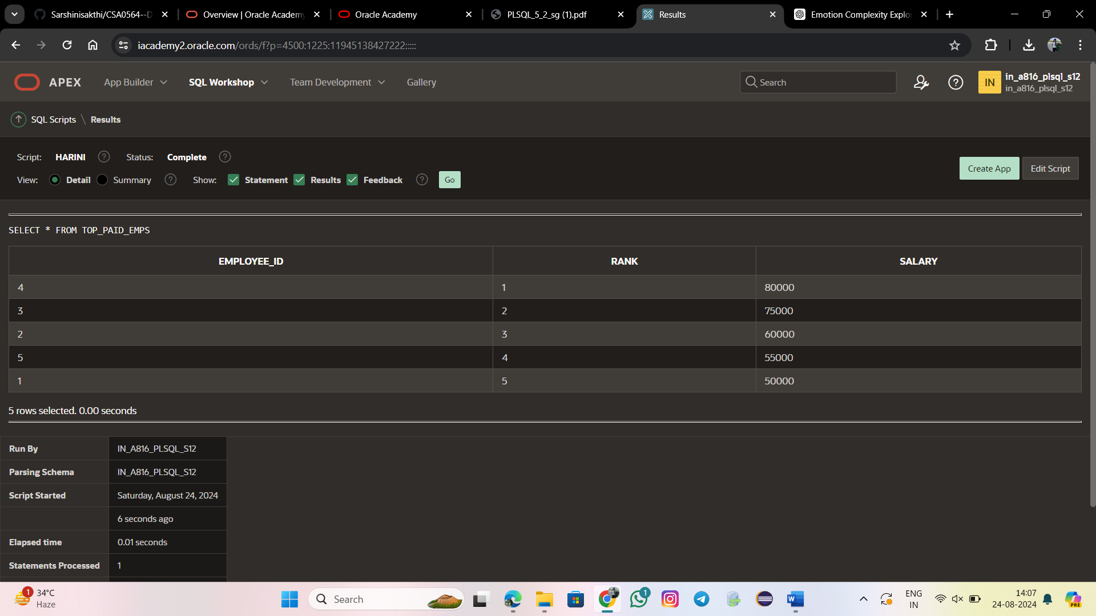

DECLARE

CURSOR cur_emps IS

SELECT employees_id, Last_name FROM EMPLOYEES

WHERE Department_Id = 60;

BEGIN

FOR v_emp_record IN cur_emps LOOP

DBMS_OUTPUT.PUT_LINE(v_emp_record.employees_id || ' '

|| v_emp_record.last_name);

END LOOP;

END;

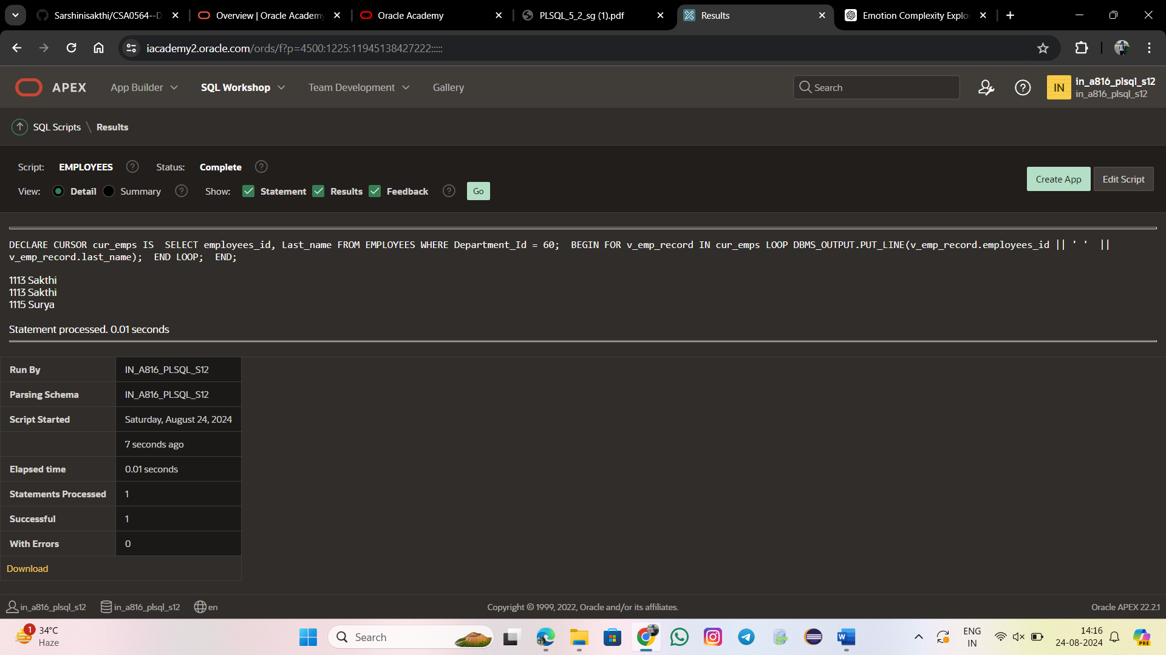

DECLARE

CURSOR cur_emps IS

SELECT * FROM employee

WHERE department_id = 71;

v_emp_record cur_emps%ROWTYPE;

BEGIN

OPEN cur_emps;

LOOP

FETCH cur_emps INTO v_emp_record;

EXIT WHEN cur_emps%NOTFOUND;

DBMS_OUTPUT.PUT_LINE(v_emp_record.employee_id || ' - '

|| v_emp_record.lastname);

END LOOP;

CLOSE cur_emps;

END;

